Year 11 Biology 2a

Task 8

Adaptations

Narrogin Senior High School
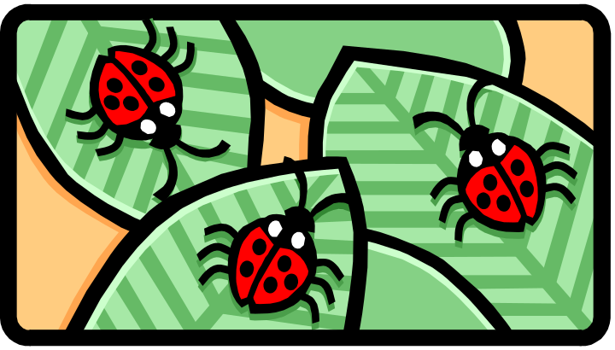

Total: 55 Marks
Section A Multichoice 25 marks

1 Which of the following adaptations would NOT be found in a plant that lives in arid areas?

(a) many stomates
(b) very small leaves
(c) a short life cycle
(d) hairs on the leaves

The following observations were made of a fish; the fish was enclosed in a bony plate had a flexible tail a flat head, propelled itself using anal spines while steering itself with pectoral fins and when resting stiffened it’s tail to look like it’s nose thus giving the illusion that it was back to front.

2 The features described above best represent which type of adaptation?

(a) structural and behavioural (b) chemical and physical
(c) physiological and structural (d) behavioural and chemical

3 Which of the following factors would not affect the amount of oxygen that could dissolve in a body of water?

(a) amount of wind blowing across the surface of the water
(b) the temperature of the water
(c) the amount of dissolved minerals found in the water
(d) the surface area of the body of water

4 An organism will survive in a particular environment because of a particular feature. This feature is best described as a

(a) mutation (b) biotic factor
(c) adaptation (d) abiotic factor

An experiment was conducted to determine the extreme salinities which each of 6 species of fish could tolerate.

FISH TYPE | SALINITY RANGE IN WHICH FISH SURVIVE  (g of salt/1000g of solution)
Electric ray | 30-36
pig fish | 10-36
barb | 0-8
flounder | 0-55
killifish | 13-76
crevalle | 0-60
(the average salinity of sea water is 35g/1000gof solution)

5 Which of the following fish would probably die if transferred from sea water to brackish water?

(a) pig fish (b) electric ray
(c) crevalle (d) killifish

6 Which of the following fish would probably be only found in fresh water?

(a) barb (b) electric ray
(c) crevalle (d) flounder

7 Which of the following techniques do plants use to prevent excessive heating if they live in an arid environment?

(a) the leaf’s cuticle is impervious to water
(b) the leaves have hairy surfaces
(c) the stomata close during the hottest part of the day
(d) the leaves hang downwards

8 The oxygen that fish obtain from water is

(a) only available to them
(b) present in tiny bubbles
(c) dissolved in the water
(d) split from the hydrogen molecule it is bonded to make water

9 The special characteristics that describe a freshwater environment would be best represented by which of the following groups of characteristics?

(a) buoyancy, viscosity, immersion in water and aquatic organisms
(b) salt in solution, buoyancy, algae and immersion in water
(c) buoyancy, viscosity, oxygen concentration and immersion in water
(d) viscosity, buoyancy, salinity, and oxygen content

10 Which of the following habitats would a fish that is able to absorb salts from the water around it against a concentration gradient be found?

(a) a freshwater lake
(b) a salt lake
(c) a temporary desert pool
(d) a tidal estuary where water varies from fresh to saline with the tides

11 To survive dry conditions a wallaby must conserve water. Which of the following would NOT help to reduce water loss from the body?

(a) production of dry faeces
(b) panting
(b) producing small quantities of concentrated urine
(d) standing stationary in the shade

12 The blood vessels found in a mammalian system that are thin enough to allow diffusion to occur across their walls are called

(a) veins
(b) capillaries
(c) arteries
(d) alveoli

13 The features of any respiratory surface that allow it to function optimally are

(a) moist surface,thin,hairy
(b) moist,thin,well supplied with blood
(c) moist,covered with mucous,well supplied with blood
(d) covered with mucous,sac like,moist many cells thick.

14 Within a plants leaf there are numerous air spaces found in between the cells. The most important effect of these air spaces is to

(a) allow the leaf to retain water
(b) allow excess water to escape
(c) allow for the rapid diffusion of gases
(d) allow for the movement of nutrients

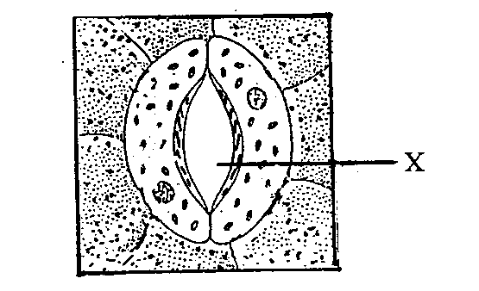
15 In the diagram above the structure labelled X is a

(a) chloroplast
(b) epidermal cell
(c) air space
(d) stomate

16 The movement of carbon dioxide out of the bloodstream and into the alveoli is achieved by the process of

(a) active transport
(b) diffusion
(c) osmosis
(d) pinocytosis

17 Blood that travels back into the heart from all over the body enters into which of the following chambers?

(a) right atrium
(b) left atrium
(c) right ventricle
(d) left ventricle

18 The lung consists of clusters of tiny sacs called alveoli. This structuring inside the lung is important because

(a) it enables a large surface area to be contained within a small volume
(b) lung tissue is quite soft and so needs to be structured in this way
(c) it is the best way to get a large blood flow to the lungs
(d) the tissue type found in the lungs is rounded epithelium

19 Which of the following organisms has what is called an open circulatory system?

(a) humans
(b) earthworm
(c) insects
(d) frog

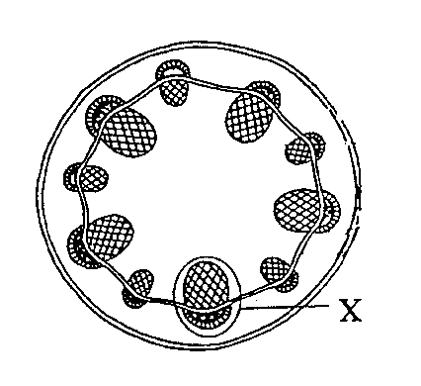
20 The structure labelled X in the diagram above is

(a) vascular bundle
(b) phloem
(c) xylem
(d) pith

21 Most birds excrete their toxic waste in the form of

(a) urea
(b) uric acid
(c) ammonia
(d) urine

22 Which of the following would be adaptations for an animal living in a desert environment?

A. large round shape
B. sweating
C. active during daylight hours
D. excretion of uric acid crystals.

(a) A and B only
(b) B and C only
(c) C and D only
(d) B and D only

23 During the breakdown of proteins ammonia is produced. This compound must be converted into urea for excretion because

(a) urea is easier to excrete
(b) ammonia is toxic to cells
(c) ammonia is not soluble in water
(d) urea can be recycled

24 The substances transported by the vascular tissue in an angiosperms are:

(a) Water and ions in the xylem; sugars in phloem.
(b) sugars in the xylem; water and ions in the phloem.
(c) minerals in the phloem; water in the xylem
(d) sugars in the xylem; minerals in the phloem

25 Which one of the following combinations correctly names a type of plant vascular tissue and a type of conducting cell that it contains?

 | Vascular Tissue | Conducting Cells
(a) | phloem | Sieve tubes, companion cells
(b) | phloem | Vessels, tracheids
(c) | xylem | Vessels, companion cells
(d) | xylem | Companion cells, sieve tube

Section B : Short Answers 30 marks

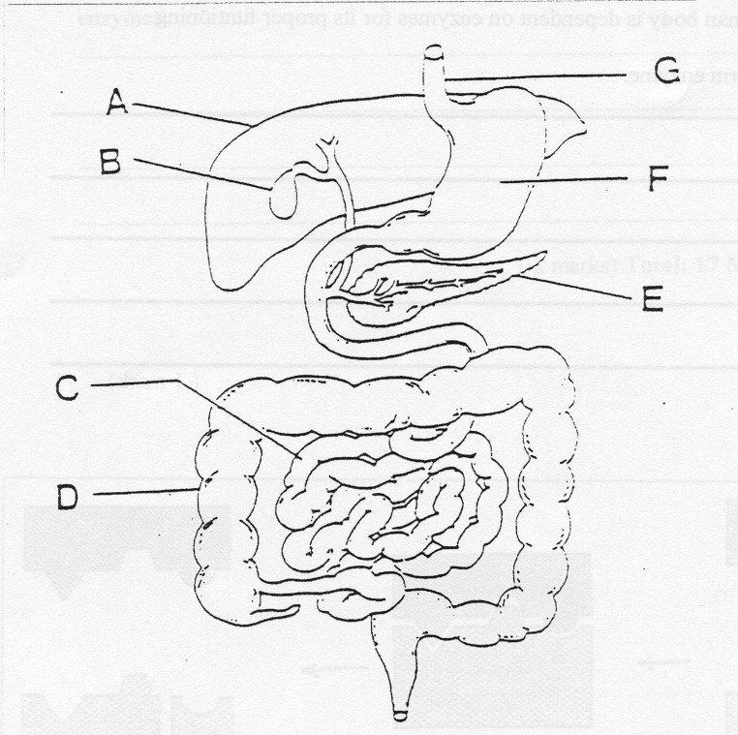

1 a) Complete the labels from the diagram above.

A ___________________________ B ______________________

C ___________________________ D ______________________

E ___________________________ F ______________________
(3 marks)

b) Discuss the role the mouth plays in terms of digestion.

________________________________________________________________________

________________________________________________________________________

________________________________________________________________________

________________________________________________________________________

________________________________________________________________________
(3 marks)

2 a) List four features that a respiratory surface has in order to maximise the diffusion of gases.
_____________________________________________________________________________________________________________________________________________________________________________________________________________________________________________________________________________________________
(4 marks)

- Name the main gas exchange problem presented by the environment.

(i) Aquatic
____________________________________________________________________________________________________________________________________

- Terrestrial
____________________________________________________________________________________________________________________________________
(2 mark)
- Name the type of gas exchange system used and explain how it functions for the following organisms.

(i) a paramecium

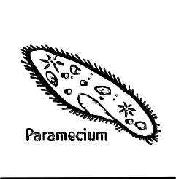
- continued
______________________________________________________________________________________________________________________________________________________________________________________________________

(ii) coachroach

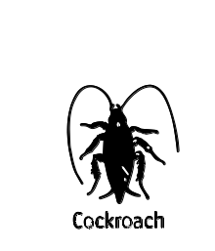
______________________________________________________________________________________________________________________________________________________________________________________________________

- fish
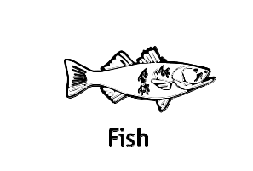
______________________________________________________________________________________________________________________________________________________________________________________________________
(6 marks)

3 Figure 3a is a diagram of a terrestrial flowering plant.

Figure 3 a

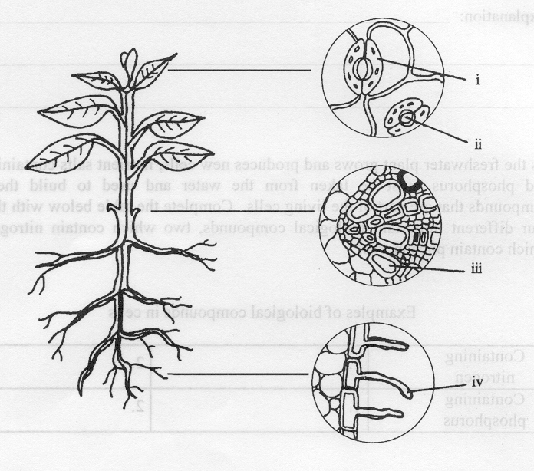

a) Use the left hand column of the table on the next page to write the name of the features or structures that are labelled i-iv in figure 3a.
(4 marks)

- Use the right hand column of the same table to state briefly the part played or the involvement of each structure in the movement of water through the plant.
(4 marks)

Symbol | Name | Role of the structure in water movement
i

ii

iii

iv

c At different times of the day, the structures which are labelled “ï” in figure 3 a may change in shape. They may appear as shown in figure 3 b or 3 c.

Figure 3b Figure 3 C
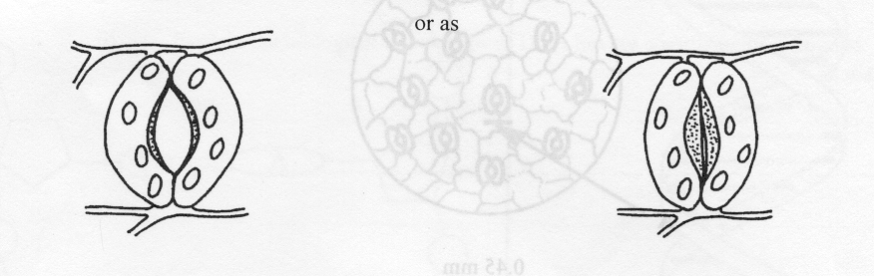

Explain the benefits that come to the plant when the structures are in each of the two conditions.

When as in Fig. 3 b: ________________________________________________

__________________________________________________________________

__________________________________________________________________

When as in Fig. 3 c: ________________________________________________

__________________________________________________________________

__________________________________________________________________
(4 marks)

